SUMMING the numbers

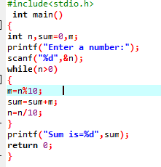

OUTPUT

